The Bolliger Lines and Pivot Points - methods of making the best decision in the Stock Exchange

Silvia Dedu, asistent univ. drd., Academy of Economic Studies, Bucharest,
tel. 0722.580269, e-mail s_dedu@yahoo.com
Florentin Şerban, asistent univ. drd., Academy of Economic Studies, Bucharest,
tel. 0723.148126, e-mail florentinserban@yahoo.com

In this paper are presented two indicators (Bolliger Lines and Pivot Points) which can be used in the technical analysis of a stock in order to optimize the terms of a transaction in the Stock Exchange. Are described techniques of using these indicators for determining the optimal moment we buy or sell a stock.

Key words: stock, Bolliger Lines, Pivot Points.

JEL classification: C40

1. Support, resistance – fundamental terms in the technical analysis of a share

The course of any share, stock market index or exchange rate evolves between diverse levels of support and resistance.
Support – represents the value of the share at which the course stops and goes back; the comeback takes place after a drop. Buyers and sellers usually see this level as a point of balance, when selling comes to a stop and the buying is commencing. The more times this point is reached, the stronger it is. When it breaks, it becomes a resistance for the past evolution.
The resistance – represents the value of a share at which the course stops and goes back; the comeback takes place after a growth. Buyers and sellers usually see this level as a point of balance, the selling starting and the buying commencing. The more the resistance is reached, the stronger it is. When it is broken, it becomes a support for the past evolution.
In the next graphic, the supports are represented by S_{x}, and the resistances by R_{x}.

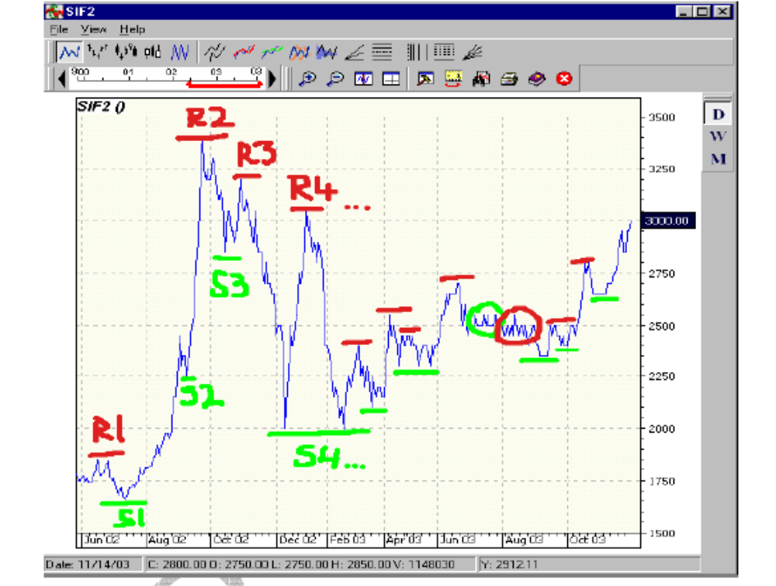
2. The Bollinger Lines (BL)

Along with the mobile medians, the Bollinger lines are probably the most important technical index. This quality comes from the observation that between them, in the space delimited by plus or minus two standard deviations towards the arithmetical average of the price from a 20-day period, there is 95% of the price population (we are talking about the closing price, „close”, even if we can use any type of price). In other words, in 95% of the cases., the closing price must be placed between these lines, having the parameter BL(2,20), where 20 is the number of the periods taken into account, and 2 represents the number of standard deviations towards the 20 day median. From 100% there are less than 5% cases in which the closing is situated outside the lines (upper or lower). Every case up to 5% will return in the space between the lines.
BL are now part of every program of technical analysis and are used mostly to determine if the actual volatility is too low or too high. A lower volatility (which means that the BL lines are closer) shows us that the action is a compressed arch. The more this period goes on, the higher the potential of a price boom. Once the price „booms” (because it will most surely do so), the volatility will grow, ending with a trend that might be descendent or ascendant. After a period of widening out, the lines tend to get closer (the volatility drops), as a result of the tendency of consolidation after a trend.
A set of Bollinger lines is characterized by the following elements:
- The arithmetical median of the price for n periods, AM(n)
- The superior BL found at +x standard deviations towards AM(n)
- The lower BL found at –x standard deviations towards AM(n)
The results obtained from applying the BL have showed us that 2 standard deviations and 10 days are a set of parameters that give relying results.

The following graphic shows us the BL(2,20) for the BRK share for the period august 2006 – february 2006:
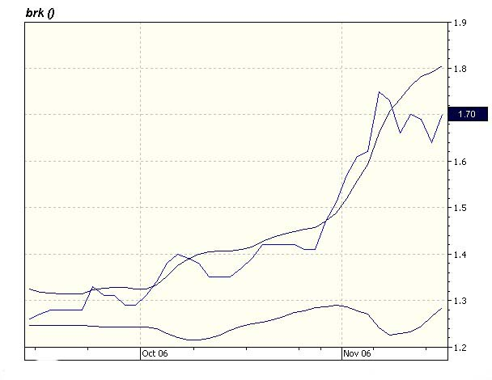
We can see a period where the volatility is very low (the BL shortens out), after which the share price booms (in our case it is a rise, but it could also have been a drop). The longer the period of low volatility, the greater the fall/rise of the price. During strong growths, the price remains in the superior part of the BL, most of the times being placed outside of it. Also, when the trend is descendent, the price is near the lower part of the BL. Any exceeding of the lower or the superior part of the BL must be followed by a return in the BL (these are the exceptions of the 5% case). Another characteristic is the fact that the price tends to the BL, but it is not necessary to exceed any line; in other words, after the price reaches the upper BL, it will then descend, going under the AM(20) and reaching the lower BL. The same process may take place if the price starts from the lower BL.

3. The Pivot Points

During a trading session, the price balances between different levels of support and resistance, levels described in the first paragraph. Generally, a pivot PP is a point at which the price is expected to change it’s course.
We will further present the five components of the pivot technique: S₂, S₁, PP, R₁, R₂ and how to calculate them.
H = the maximum price level from the last day
L = the minimum price level from the last day
C = the closing price from the last day

Pivot 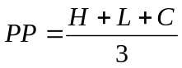
First support 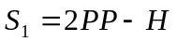
First resistance 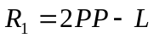
Second support 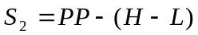
Second resistance 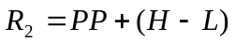

The pivot must consider the first value that should be taken into account before entering a transaction. Only when we reach this point we will be able to know if we should enter or exit a transaction. Generally, if the price is above PP, the situation is considered as „bullish”, and if not, it is a „bearish” situation.
Let’s assume that when the trading session starts, the price is below PP. S₁ and S₂ are the the next inferior levels that can be touched (theoreticaly) , but it is not necessary. If S₂ is reached, it is not recommanded to buy the share, but we should wait until the price rises, reaches PP and goes further towards R₁. If at the begining of the trading session the price is above the PP, them R₁ and R₂ are goals that should be reached and that may offer profit: if the price excedes R₁, we will have a selling point right (stop-loss) under R₁. If the price excedes R₂, a stop-loss is appied right under R₂. This way, the ascending trend can be used and if the price returns, the stop-losses may keep the gains and takes us away from a descending trend. The technique of „Pivot Points” is very simple, but it does not mean that the points are reached constantly. For an improved performance, it is recommanded to use this technique for shares with a high range of the price (a high H-L, meaning a high volaility) and a high liquidity.
The usage of the pivot point technique
Usually, the crossing of an index with it’s average median produces points of entrance and exit (who’s frequency depends if the median is made on more or less periods). We will use two new indexes, PP SMA3, which is SMA (Pivot,3), meaning the simple mobile median of the index pivot on a period of 3 days, and
PP SMA5, meaning SMA(Pivot,5).
If the pivot is located above the PP SMA3, then the daily trend is considered as beeing ascendent. If PP is below PP SMA3, then the daily trend is considered as beeing descendent. PP SMA5 is used to find the weekly trend. In the same way, if PP is above PP SMA5, the trend is pozitive, and if not, it is negative. The next table presents the data into a more simple way:

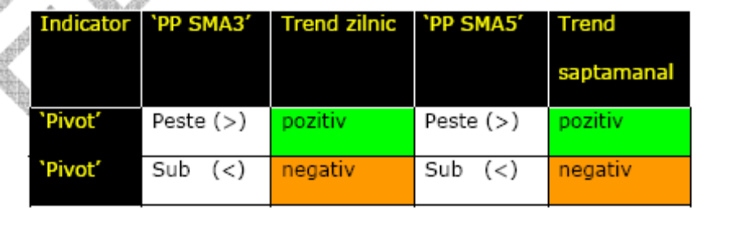

4. Conclusions

One of the most important issues from the stock market is the finding of the optimal moment for the selling or buying of a share. The Bollinger Lines (presented in 2.) and the Pivot Points (presented in 3.) are two of the indexes that can be used in a technical analysis of a share in order to optimize the conditions of a transaction. It is recommanded that, before making the decission of buying or selling of a share, these indexes sould be consulted and the decission has to be made related to their value.

Bibliography

1. Dalton, J. M., How the Stock Markets Works, New York Institute of Finance, Prentice-Hall, 1988

2. Popa, I., Bursa, Editura Adevărul S.A., Bucureşti, 1994

3. *** Collection “Bursa”

4. *** Collection “Capital”

5. *** Collection “Ziarul Financiar”

6. *** www.bvb.ro

7. *** www.educofin.ro

8. *** www.primet.ro

